Lake of the Isles Lutheran Church

 Christ the King Sunday
November 26, 2017

On this final Sunday of the church year our gospel is Jesus’ great story of judgment. In the end, the faithful are those who served Christ by ministering to those who are poor, hungry, naked, sick, or estranged. In the first reading God is the shepherd who seeks the lost, weak, and injured and feeds them with justice. We gather this day to celebrate the reign of Christ and his victory over death, yet awaiting the consummation of all things yet to come. Acknowledging Christ as our merciful ruler, we go forth that his reign may be known in our loving words and deeds.



Inspired by Christ,
living and growing in faith,
we are a loving and open community
of worship, witness, and service in God’s world.

  Prelude  Welcome  Call to Worship  Please stand as you are able    Gathering Hymn  Apostolic Greeting  Prayer of the Day  Please be seated.      Baptism Hymn  (Please join in singing the refrain.)    Ezekiel 34:11-16, 20-24  Since Israel’s kings proved to be bad shepherds, Ezekiel declares that the Lord will assume the role of shepherd in Israel. The Lord will also set over them a shepherd-messiah, “my servant David,” who will feed and care for the people.    Please stand as you are able.  Matthew 25:31-46  Jesus compares himself to a king who moves among his subjects to see how he is treated: what is done for the least of those who belong to his family is truly done for him.  Please be seated  Hymn of the Day  Please stand as you are able.    Congregation, please be seated  Anthem  Offertory  Please stand as you are able.  The response concludes with “Amen.”  Offertory Prayer  1.  Sing through one time, then lectern side sings 1 & 2, pulpit side sings 2 & 1  2.   |  Gathering   Following the call of God’s Spirit, the community of faith gathers,  welcoming one another and praying for God’s mercy to fill the church and the world.  We invite you to use the prelude time to prepare your heart and mind for worship.  Prelude on Lo! He Comes With Clouds Descending  K. Vigne  Psalm 95  Come, let us sing to the Lord; let us shout for joy to the rock of our salvation.  Let us come before God’s presence with thanksgiving and raise a loud shout to the Lord with psalms.  For you, Lord, are a great God, and a great ruler above all gods.  In your hand are the caverns of the earth; the heights of the hills are also yours.  The sea is yours, for you made it, and your hands have molded the dry land.  Come, let us worship and bow down, let us kneel before the Lord our maker.  For the Lord is our God, and  we are the people of God’s pasture and the sheep of God’s hand  Glory be to the Father and to the Son and to the Holy Spirit  As it was in the beginning is now and will be forever. Amen  Jesus Shall Reign  ELW #434  Vs 1 All, vs 2, vs 3 All, vs 4 Men and vs 5 All  P: The grace of our Lord Jesus Christ, the love of God, and the communion of the Holy Spirit be with you all.  C: And also with you.  O God of power and might, your Son shows us the way of service, and in him we inherit the riches of your grace. Give us the wisdom to know what is right and the strength to serve the world you have made, through Jesus Christ, our Savior and Lord, who lives and reigns with you and the Holy Spirit, one God, now and forever. Amen.  THE SACRAMENT OF HOLY BAPTISM  Avery Rose Schliep  Parents: Matthew and Kaley Schliep  Sponsors: Molly and Patrick McGlynn  Presentation  Profession of Faith  P: I ask you to profess your faith in Christ Jesus, reject sin, and confess the faith of the church. Do you renounce of evil, the devil and all his empty promises?  C: I do  P: Do you believe in God the Father?  C: I believe in God, the Father Almighty, creator of heaven and earth.  P: Do you believe in Jesus Christ, the Son of God?  C: I believe in Jesus Christ, God’s only son, our Lord, who was conceived by the Holy Spirit, born of the virgin Mary, suffered under Pontius Pilate, was crucified, died and was buried; he descended to the dead. On the third day he rose again; he ascended into heaven, he is seated at the right hand of the Father, and he will come to judge the living and the dead.  P: Do you believe in God the Holy Spirit?  C: I believe in the Holy Spirit, the holy catholic church, the communion of saints, the forgiveness of sins, the resurrection of the body, and the life everlasting. Amen.  Thanksgiving at the Font  Congregation may be seated.  Baptism  C: We welcome you into the Lord’s family. We receive you as a fellow member of the body of Christ, a child of the same heavenly Father, and a worker with us in the kingdom of God.  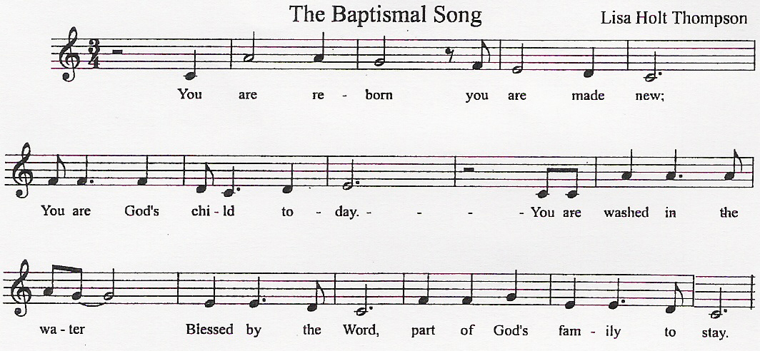   Word   The Word of God comes alive for the gathered community  As God speaks to us in scriptures read, sung and preached.  Reading  ¹¹Thus says the Lord God: I myself will search for my sheep, and will seek them out. ¹²As shepherds seek out their flocks when they are among their scattered sheep, so I will seek out my sheep. I will rescue them from all the places to which they have been scattered on a day of clouds and thick darkness. ¹³I will bring them out from the peoples and gather them from the countries, and will bring them into their own land; and I will feed them on the mountains of Israel, by the watercourses, and in all the inhabited parts of the land. ¹⁴I will feed them with good pasture, and the mountain heights of Israel shall be their pasture; there they shall lie down in good grazing land, and they shall feed on rich pasture on the mountains of Israel. ¹⁵I myself will be the shepherd of my sheep, and I will make them lie down, says the Lord God. ¹⁶I will seek the lost, and I will bring back the strayed, and I will bind up the injured, and I will strengthen the weak, but the fat and the strong I will destroy. I will feed them with justice.  ²⁰Therefore, thus says the Lord God to them: I myself will judge between the fat sheep and the lean sheep. ²¹Because you pushed with flank and shoulder, and butted at all the weak animals with your horns until you scattered them far and wide, ²²I will save my flock, and they shall no longer be ravaged; and I will judge between sheep and sheep.  ²³I will set up over them one shepherd, my servant David, and he shall feed them: he shall feed them and be their shepherd. ²⁴And I, the Lord, will be their God, and my servant David shall be prince among them; I, the Lord, have spoken  R: Word of God, Word of Life.  C: Thanks be to God.  Alleluia  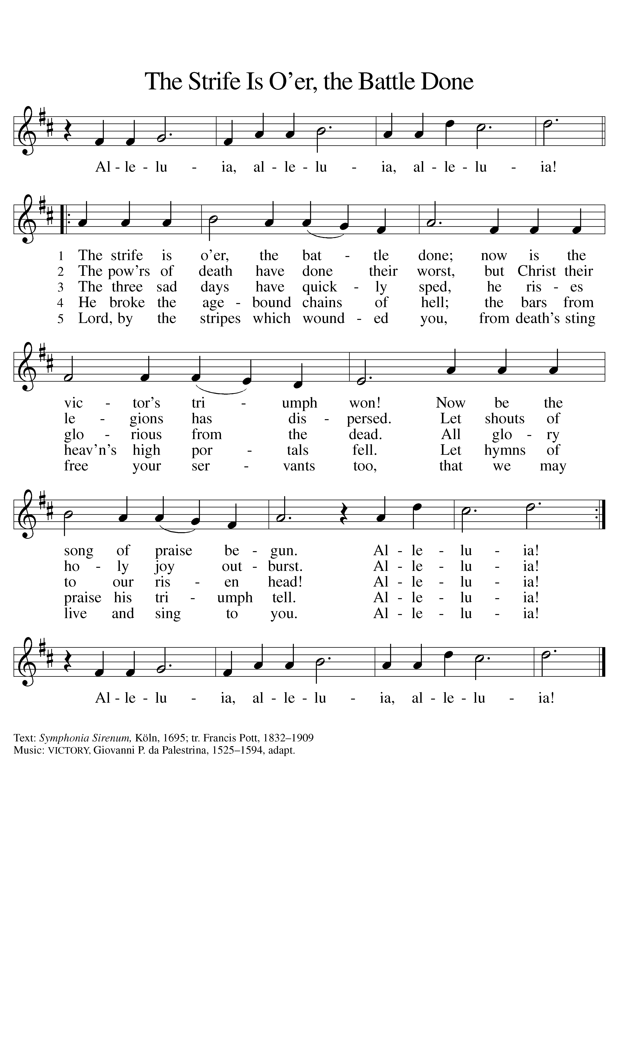  P: The Holy Gospel according to St. Matthew, the twenty-fifth chapter.  C: Glory to you, O Lord.  Gospel  [Jesus said to the disciples:] ³¹“When the Son of Man comes in his glory, and all the angels with him, then he will sit on the throne of his glory. ³²All the nations will be gathered before him, and he will separate people one from another as a shepherd separates the sheep from the goats, ³³and he will put the sheep at his right hand and the goats at the left. ³⁴Then the king will say to those at his right hand, ‘Come, you that are blessed by my Father, inherit the kingdom prepared for you from the foundation of the world; ³⁵for I was hungry and you gave me food, I was thirsty and you gave me something to drink, I was a stranger and you welcomed me, ³⁶I was naked and you gave me clothing, I was sick and you took care of me, I was in prison and you visited me.’ ³⁷Then the righteous will answer him, ‘Lord, when was it that we saw you hungry and gave you food, or thirsty and gave you something to drink? ³⁸And when was it that we saw you a stranger and welcomed you, or naked and gave you clothing? ³⁹And when was it that we saw you sick or in prison and visited you?’ ⁴⁰And the king will answer them, ‘Truly I tell you, just as you did it to one of the least of these who are members of my family you did it to me.’ ⁴¹Then he will say to those at his left hand, ‘You that are accursed, depart from me into the eternal fire prepared for the devil and his angels; ⁴²for I was hungry and you gave me no food, I was thirsty and you gave me nothing to drink, ⁴³I was a stranger and you did not welcome me, naked and you did not give me clothing, sick and in prison and you did not visit me.’ ⁴⁴Then they also will answer, ‘Lord, when was it that we saw you hungry or thirsty or a stranger or naked or sick or in prison, and did not take care of you?’ ⁴⁵Then he will answer them, ‘Truly I tell you, just as you did not do it to one of the least of these, you did not do it to me.’ ⁴⁶And these will go away into eternal punishment, but the righteous into eternal life.”  P: The Gospel of our Lord.  C: Praise to you, O Christ.  Sermon Following the sermon, we will take a moment of silence to reflect on today’s gospel message.  Lo, He Comes with Clouds Descending  ELW #435  Prayers of the Church  P: Welcoming God’s reign of righteousness and mercy, let us pray with people of every time and place.  A: Almighty God, your merciful rule encompasses all the world. As we gather for worship in safety, ...Lord, in your mercy,  C: hear our prayer.  P: Into your hands, God of abundant grace, we commend all for whom we pray, trusting in your mercy, through Jesus Christ, our Savior.  C: Amen.  Greeting of Peace  P: The peace of the Lord be with you always.  C: And also with you.  After the greeting, please share a word of peace with your neighbors.   Offering   Lake of the Isles Lutheran Church is supported through the generous gifts of time, talent and treasure of our friends and members. In order to fulfill our mission and ministry, we need to receive approximately $6,000 in offerings each week. We thank you for your support and partnership in the proclamation of the good news.  The King Shall Come  Arnold B. Sherman  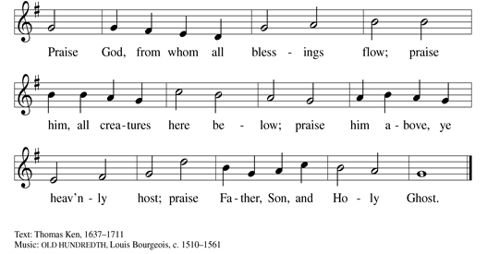  A: Creator God, you made everything, and you provide for every need. The bread we break and the wine we pour come from you. As we eat and drink with thanksgiving, fill us with your love; let that love flow through us to others; and join us to the saints before us in a holy and boundless communion; through Jesus Christ our Lord.  C: Amen.   Meal   We lift our hearts with praise and thanksgiving as the table is set,  and we receive the bread and wine—the humble meal through which we are fed by the presence of Jesus the Christ and united as the body of Christ in the world.  Great Thanksgiving  P: The Lord be with you.  C: And also with you.  P: Lift up your hearts.  C: We lift them to the Lord.  P: Let us give thanks to the Lord our God.  C: It is right to give our thanks and praise.  P: It is indeed right, our duty and our joy…we praise your name and join their unending hymn  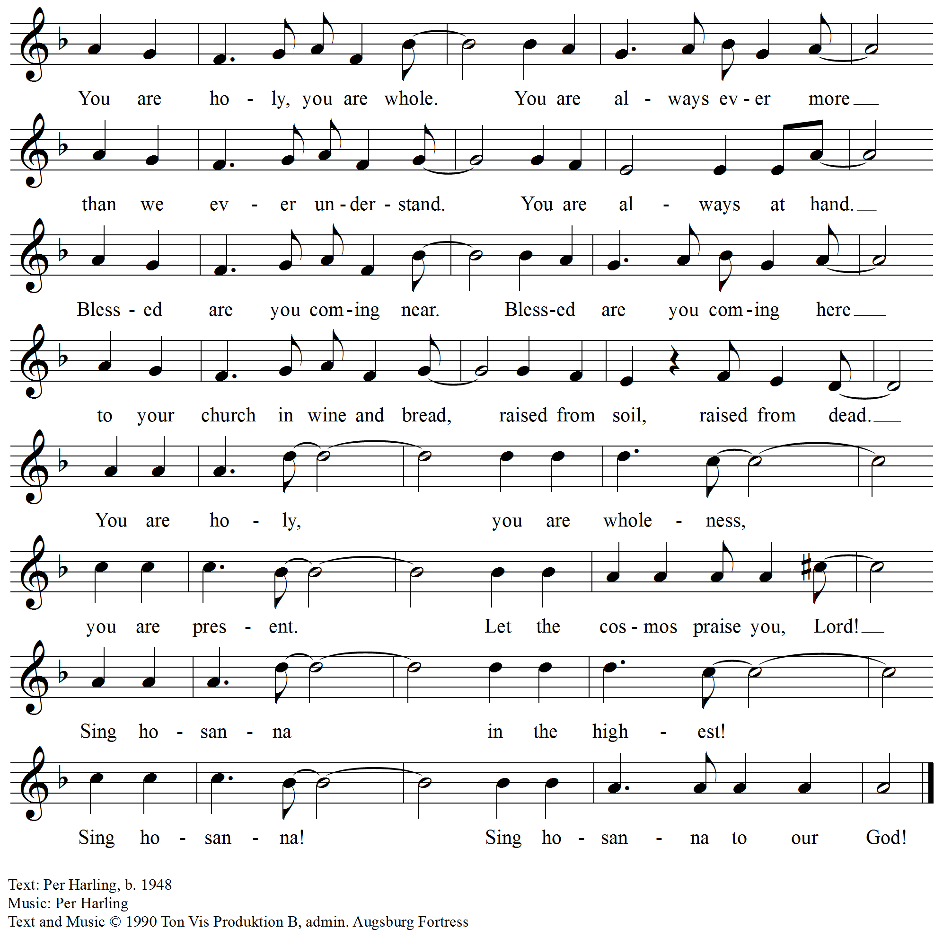  Words of Institution  The Lord’s Prayer  Our Father in heaven, hallowed be your name, your kingdom come, your will be done, on earth as in heaven. Give us today our daily bread. Forgive us our sins as we forgive those who sin against us. Save us from the time of trial and deliver us from evil. For the kingdom, the power, and the glory are yours, now and forever. Amen.
Invitation to Communion  P: Come to me all who are tired and heavy laden, and I will give you rest. The table is ready. All are welcome.  Please be seated  Lamb of God  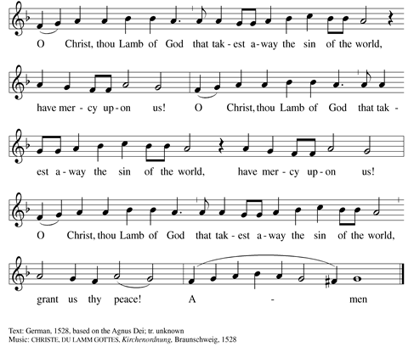  Meditation  Distribution  Communion is by common cup or intinction: For the common cup, receive a piece of the bread, and drink from the white chalice. For intinction dip the bread into the brown cup with the wine (dark) or grape juice (light) as you prefer, then eat. At Lake of the Isles, we practice open communion. All who hunger for the presence of Christ in their life are welcome at this table.  Post-Communion Blessing  P: The body and blood of our Lord Jesus Christ strengthen you and keep you in his grace.  C: Amen.  Post-Communion Prayer  A: We come again to you, O God, giving you thanks that in this feast of mercy you have embraced us and healed us, making us one in the body of Christ. Go with us on our way. Equip us for every good work, that we may continue to give you thanks by embracing others with mercy and healing; through Jesus Christ, our Savior and Lord.  C: Amen.   SENDING   We receive the blessing of God and leave in peace,  Sent out to live the way of Jesus for the sake of the world God loves.  Soon and Very Soon  ELW #439  Benediction  P: The Lord bless you and keep you.  The Lord make his face shine on you and be gracious to you.  The Lord look upon you with favor and + give you peace.  C: Amen.  Announcements  Dismissal  P: Go in peace. Serve the Lord.  C: Thanks be to God.  Postlude Fanfare J. Lemmens  You are invited to leave quietly during the Postlude or to remain to enjoy this musical offering of thanksgiving and praise.  Bulletin liturgy and hymnody reprinted under CCLI license #1821244 and or OneLicense.net #A-704053 |  | Agnus Dei    Distribution Music  Please stand as you are able.    Sending Hymn

Welcome
We thank you for celebrating the love of Jesus Christ with us this week, and we invite you back
again—for prayer and worship and to any of the events our congregation has scheduled. We
hope the message of God’s grace will guide and strengthen you as you grow in love and faith in
your daily life.

Your worship Pastor Rev. Dr. Arden D. Haug
leaders today Organist Kenneth Vigne
Choir Director Dawn Allan
Baptism Song Mark Waldeland and Kathy Hering
Worship Assistant Kathy Hering
Reader Steve Hoyt
Ushers David and Carolyn Hagford
Altar Servers Kathy Hering and Margaret Coleman
Communion Assistants Denise Wilkens, Bruce & Jean Carlson
Coffee Host Janna Haug, Pauline Haug and Rick Gripentrog

Church officers President Martin Carlson
Vice President Ross Formell
Treasurer Ross Bartels

staff Children’s Ministry Director Diane LaMere
Office Manager Linda Nelson
Custodian Dane Peterson
Nursery Attendant Sheridan Swee
Calendar
Sunday, November 26 9:30 am Worship with Holy Communion Sanctuary
9:45 am Sunday School Sunday School Rooms
10:40 am Coffee Hour Sanctuary
11:00 am Christmas Tea Meeting Fellowship Hall
Monday, November 27 7:45 am Kenwood School Dance Rehearsal Fellowship Hall
7:00 pm AA Fellowship Hall
Tuesday, November 28 5:15 pm SA Support Group Christy Room
7:00 pm AA Spiritual Recovery Group Christy Room
7:00 pm Men’s AA Group Sunday School Room
Wednesday, November 29 7:45 am Kenwood School Dance Rehearsal Fellowship Hall
10:00 am Bible Study Christy Room
12:00 pm Staff Meeting Fellowship Hall
7:00 pm Confirmation Christy Room 7:30 pm Choir Practice Fellowship Hall
Thursday, November 30 12:00 pm Al Anon Fellowship Hall
7:00 pm Women’s Bible Study Library
Friday, December 1 7:45 am Kenwood School Dance Rehearsals Fellowship Hall
Saturday, December 2 9:30 am Priscilla Circle Christy Room
1:00 pm Knitting Group Christy Room
Sunday, December 3 9:30 am Worship with Holy Communion Sanctuary
9:45 am Sunday School Sunday School Rooms
10:40 am Coffee Hour Fellowship Hall
10:45 am Family Advent Festival Fellowship Hall

ANNOUNCEMENTS

PRAYER LIST

Please keep the following friends & members of our community of faith in your prayers of thanksgiving or for comfort, peace, and healing:
Marlene Wilson, Shirley Carlson, John Slama, -son-in-law of Ellie Holmquist, LOTI members; Judy Bigelow; Sam Pederson, nephew of Jenny Cook; Vangie Hagfors, cousin of Dave Hagford. Lynn Williamson, family of Bruce and Carol Kuehn.
_________________________________________
STAFFED NURSERY AVAILABLE
Children are always welcome in worship, however, if the need arises, the Christy Room is staffed with a Nursery Attendant for your child. The Christy Room is located to the left of the sanctuary through the side door at the front of the church and across from the church office. There is an alternate route to take from the narthex—follow the signs. If you need assistance, please ask one of the ushers to help you. There is a baby changing table available in the unisex restroom between the pastor’s office and the sacristy.


Nancy McCutcheon 11/28 | Vitali Haug  11/30
______________________________________
Loved Ones In The Military  Please keep all the members and families of the military in your prayers of  thanksgiving and protection. | 
____________________________________________
CHRISTMAS DECORATION THANK YOU
Thank you also to Lee and Marlene Wilson for providing the beautiful Christmas pots that sit on either side of the side entrance door on W. 21st Street. We really appreciate how it dresses up that entrance to the church.
____________________________________________
CHRISTMAS TEA AND COOKIE SALE
MEETING NOVEMBER 26TH
11:00 A.M.
The tea and cookie sale will be held on Sunday, December 10Th. Please call Linda in the church office if you can help with one or both of these events. We will have a short meeting after the service in Fellowship Hall for planning purposes.
____________________________________________
FAMILY ADVENT FESTIVAL
SUNDAY, DECEMBER 3RD AT 10:45 A.M.
Come join us in Fellowship Hall after worship, an intergenerational event for all ages. There will be lots of fun projects to choose from.
___________________________________________
FAITH ‘N PLAY
TUESDAY, DECEMBER 12
9:30 TO 10:30 A.M.
This new faith opportunity is designed for families with toddlers and pre-schoolers. What is Faith 'n Play? We will do just that - practice faith together and play in the story. It will be a very hands-on and interactive experience for parent and child together. Please RSVP to Diane LaMere (diane.lamere@loti.org) if you can come to our second gathering on December 12.
____________________________________________
SCAN TO GIVE

____________________________________________

COLLEGE CARE PACKAGES
HAVE BEEN SHIPPED
Thank you for your generous support of the college care packages. Thanks to you...the packages are filled with lots of healthy snacks, (and some candy too!), tools for studying and staying healthy plus a few things that are "just for fun". The cards the kids made on Sunday will absolutely make them smile :) . The packages will arrive just in time for final exams.
_______________________________________
WOMEN’S BOOK CLUB
Women's Book Club will meet on Friday, December 15, not December 9, at 5:00pm at Deb Gilroy's home close to LOTI. Beverages and snacks will be served. Feel free to bring something to share if you wish. We will discuss "The Red Tent" by Anita Diamante. This is a fabulous book with lots of discussion possibilities. Many of us have read it before but felt it was worthwhile to discuss for our first meeting. If you've never read it, you're in for a treat!
____________________________________________
SIGN UP NOW TO SERVE A MEAL AT OUR SAVIOUR'S HOUSING
Lake of the Isles Lutheran Church has provided a meal for 40 the first Friday of every month for many years. This is a wonderful opportunity for families or a group of friends. Check your calendars and pick a month now for 2018. You can reserve your month by calling or emailing Cheri Moe (952-431-5226, moeclana@aol.com). She can provide you with recipes for a crowd. If you are a Thrivent member, you can apply for a Thrivent Action grant that will cover the cost of the meal as well as some left over to purchase the supplies that Our Saviour's is always in need of.
____________________________________________
WINTER COAT DRIVE SUCCESS
Thank you for your amazing response to the winter coat/gear drive for PPL. We filled their van with winter coats, hats, gloves, snow pants, snow boots, scarves, sweaters, fleece tops, blankets, socks and long underwear. 181 total items were donated. Amazing - thank you for helping take care of others in our community in need of help!
____________________________________________

EXTENDED CALENDAR
Of LOTI CHURCH SERVICES
& Events


Sunday Worship Services
& Sunday School
9:30 a.m.

November 30
Women’s Bible Study
7:00 p.m.

December 2
Priscilla Circle
9:20 a.m. at Jean Carlson’s Home

December 3
1st Sunday of Advent
9:30 a.m. Service

Family Advent Festival
10:45 a.m.
Fellowship Hall

December 10
Lessons and Carols
Christmas Tea

December 12
Faith & Play
9:30 a.m. to 10:30 a.m.

December 16
Sunday School Christmas
Program Rehearsal
10:00 to 11:00 a.m.

Children’s Opera
12:00 to 1:00 p.m.

December 17
Children’s Christmas Pageant
Santa Lucia

Traditional JULBORD
“Christmas Smorgasbord”
12:00 or 4:00 p.m. Seatings
Seating Limited
Call the church office

December 24
Sunday Worship Service
9:30 a.m.
Christmas Eve
Family Service at 4:30 p.m.
Candlelight Service at 10:00 p.m.

God’s Help, Our Hands
2020 W. Lake of the Isles Parkway
Minneapolis, MN 55405
 612 377-5095 
Office Hours:
M-F 9:00 a.m. to 4:00 p.m.
churchoffice@loti.org  pastor@loti.org
Visit our website at: www.loti.org
Like us on Facebook: Lake of the Isles
Lutheran Church
Follow us on Twitter: @LOTICHURCH
1936 - 2017

