Lake of the Isles Lutheran Church

 Christmas Eve Candlelight Service 
10:00 p.m.
December 24, 2017

On a long winter evening we gather to proclaim the coming of the light. Isaiah announces that the people who walked in darkness have seen a great light. In the familiar account of Christ's birth, the evening sky is bright with the heavenly host singing, "Glory to God in the highest." Amid our broken world we proclaim that the prince of peace is born among us. God comes to us in human flesh—in Christ’s body and blood—so that we may be bearers of divine light to all the world.

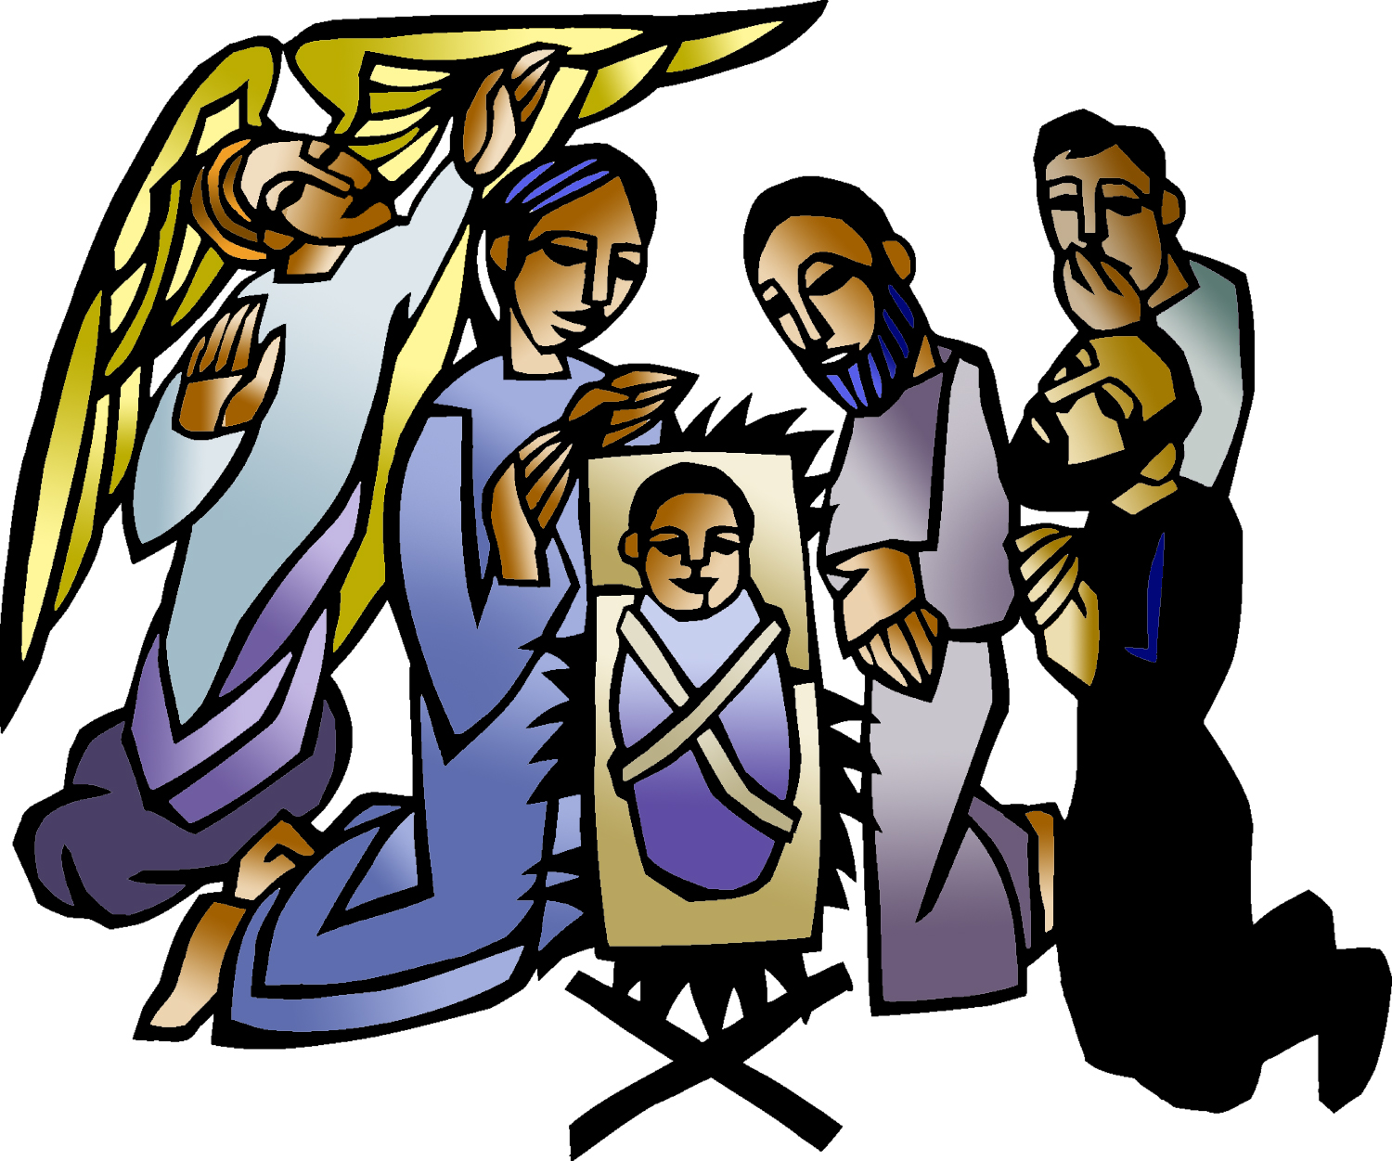

Inspired by Christ,
living and growing in faith,
we are a loving and open community
of worship, witness, and service in God’s world.
  Prelude  Welcome  Processional Hymn  Please stand as you are able.  Apostolic Greeting  Prayer of the Day  Please be seated.  Isaiah 9:2b, 6-7  Saint Luke 2:1-7  Saint Luke 2:8-12  Saint Luke 2:13-20  Saint John 1:1-5, 10-14  Please stand as you are able.  The congreg-ation may be seated. |  Gathering   Following the call of God’s Spirit, the community of faith gathers,  welcoming one another and praying for God’s mercy to fill the church and the world.  We invite you to use the prelude time to prepare your heart and mind for worship.  Passacaglia on Stille Nacht  K. Vigne  Many ages after God created the heavens and the earth,  when man and woman were formed in God’s own image;  long after the great flood, when God set the rainbow  in the clouds as a sign of the covenant;  twenty-one centuries from the time of Abraham and Sarah;  thirteen centuries after Moses led God’s people to freedom;  eleven centuries from the time of Ruth and the judges;  a thousand years from the anointing of David as king;  in the sixty-fifth week as Daniel’s prophecy takes note;  in the one hundred and ninety-fourth Olympiad;  the seven hundred and fifty-second year  from the founding of the city of Rome;  the forty-second year of the reign of Octavian Augustus;  in the sixth age of the world, all earth being at peace,  Jesus Christ, eternal God, Son of the eternal Father,  willing to hallow the world by his coming in mercy,  was born of the virgin Mary in Bethlehem of Judea.  Today is the birth of our Lord Jesus Christ, God made flesh.  O come, let us adore Him.  Adeste Fidelis  Oh, Come, all ye faithful, Joyful and triumphant!  Oh, Come, ye, oh, Come ye to Bethlehem;  Come and behold him Born the king of angels:  Refrain: Oh come, let us adore him, Oh, come let us adore him,  Oh, come let us adore him, Christ the Lord!  The Highest, most holy, Light of light eternal,  Born of a virgin, a Mortal he comes;  Son of the Father Now in flesh appearing! Refrain.  Sing, choirs of angels, Sing in exultation,  Sing, all ye citizens of heaven above!  Glory to God… In…the .. Highest: Refrain.  Yea, Lord, We greet thee, born this happy morning;  Jesus, to thee be glory giv’n!  Word of the Father, now in flesh appearing: Refrain.  P: The grace of our Lord Jesus Christ, the love of God, and the communion of the Holy Spirit be with you all.  C: And also with you.  P: Almighty God,  C: you made this holy night shine with the brightness of the true Light. Grant that here on earth we may walk in the light of Jesus’ presence and in the last day wake to the brightness of his glory; through your only Son, Jesus Christ our Lord, who lives and reigns with you and the Holy Spirit, one God, now and forever. Amen.  Lesson  The people who walked in darkness have seen a great light; those who lived in a land of deep darkness- on them light has shined. For a child has been born for us, a son given to us; authority rests upon his shoulders; and he is named Wonderful, Counselor, Mighty God, Everlasting Father, Prince of Peace. His authority shall grow continually, and there shall be endless peace for the throne of David and his kingdom. He will establish and uphold it with justice and with righteousness from this time onward and forevermore. The zeal of the LORD of hosts will do this.  R: Word of God, Word of Life.  C: Thanks be to God.  The Reading of the Christmas Gospel  Welcome, Thou King of Glory  Vincent Luebeck  Oh, welcome, Bridegroom dear, Thou King of highest glory,  Oh, welcome Jesus Lamb of God, I’ll sing Thy praise, forever.  In ev’ry hour of ev’ry day, My heart will sing Thy praise alway.  To save us from damnation, Thou wast made man for our salvation.  In those days a decree went out from Caesar Augustus that all the world should be registered. This was the first registration and was taken while Quirinius was governor of Syria. All went to their own towns to be registered. Joseph also went from the town of Nazareth in Galilee to Judea, to the city of David called Bethlehem, because he was descended from the house and family of David. He went to be registered with Mary, to whom he was engaged and who was expecting a child. While they were there, the time came for her to deliver her child. And she gave birth to her first-born son and wrapped him in bands of cloth, and laid him in a manger, because there was no room for them in the inn.  O noble deed! O glorious night! What love to us given!  For us the Savior deigns to fight To conquer earth and heaven.  A man of might and pow’r He came And fire and cloudburst held in rein  ‘Fore whom the heav’ns are shaking. And all the hills are quaking.  In that place there were shepherds living in the fields, keeping watch over their flocks by night. Then an angel of the Lord stood before them, and the glory of the Lord shone around them, and they were terrified. But the angel said to them, “Do not be afraid; for see- I am bringing you good news of great joy for all the people: to you is born this day in the city of David a Savior, who is Christ, the Lord. This will be a sign for you: you will find a child wrapped in bands of cloth and lying in a manger.”  O dearest Babe, O sweetest Child, Most gracious is Thy bearing.  Come, Brother, whom I hold more dear Than all my wealth and living;  Come enter Thou my heart today, Come quickly from Thy bed of hay,  Come, come to me, my Savior , And live in me forever.  And suddenly there was with the angel a multitude of the heavenly host, praising God and saying, “Glory to God in the highest heaven, and on earth peace among those whom he favors!” When the angels had left them and gone into heaven, the shepherds said to one another, “Let us go now to Bethlehem and see this thing that has taken place, which the Lord has made known to us.” So they went with haste and found Mary and Joseph, and the child lying in the manger. When they saw this, they made known what had been told them about this child; and all who heard it were amazed at what the shepherds told them; and all who heard it were amazed at what the shepherds told them. But Mary treasured all these all these words and pondered them in her heart. The shepherds returned, glorifying and praising God for all they had heard and seen, as it had been told them.  I pray Thee, blessed Bridegroom mine. My Hope, my Joy and Pleasure,  Thou noble Branch of David’s line, How shall I share with Thee my treasure?  Ah, let me give my body and soul, In all things make Thy way my goal.  I will be Thine forever.  Gospel of the Incarnation  In the beginning was the Word, and the Word was with God, and the Word was God. He was in the beginning with God. All things came into being through him, and without him not one thing came into being. What has come into being in him was life, and the life was the light of all people. The light shines in the darkness, and the darkness has not overcome it. He was in the world, and the world came into being through him; yet the world knew him not. He came to his own home, and his own people received him not. But to all who received him, who believed in his name, he gave the power to become the children of God, who were born, not of blood, nor of the will of the flesh, nor of the will of man, but of God. And the Word became flesh and dwelt among us, and we have beheld his glory, the glory as of a father’s only son, full of grace and truth.  Praise, thanks, and glory, Jesus Christ, to Thee in song I offer;  For as my Brother Thou wast born And all the world didst conquer.  Help me to cherish and to praise Thee ever in this time of grace  And then in heav’n victorious I’ll praise Thy name most glorious.  Sermon
Hark! The Herald Angels Sing  Hark! The herald angels sing, “Glory to the newborn king;  Peace on earth, and mercy mild, God and sinners reconciled.”  Joyful, all ye nations, rise; Join the triumph of the skies;  With angelic hosts proclaim, “Christ is born in Bethlehem!”  Hark! The herald angels sing, “Glory to the newborn king!  Christ, by highest heav’n adored, Christ, the everlasting Lord,  Late in time behold him come, Offspring of a virgin’s womb.  Veiled in flesh the Godhead see! Hail, incarnate deity!  Pleased as man with us to dwell, Jesus, our Emmanuel!  Hark! The herald angels sing, “Glory to the newborn king!”  Hail, the heav’n born Prince of Peace! Hail, the Sun of righteousness!  Light and life to all he brings, Ris’n with healing in his wings.  Mild he lays his glory by, Born that we no more may die,  Born to raise each child of earth, Born to give us second birth.  Hark! The herald angels sing, “Glory to the newborn king!”   Offering   Lake of the Isles Lutheran Church is supported through the generous gifts of time, talent and treasure of our friends and members. We thank you for your support and partnership in the proclamation of the good news.  Ah, Dearest Jesu, Holy Child  Martin Luther & Robert Wetzler  Ah, dearest Jesu, Holy Child, Make thee a bed, soft undefiled  Within my heart, that it may be A quiet chamber kept for thee.  To us this night is born a Child of Mary, chosen mother mild.  This little Child of lowly birth, Shall be the joy of all the earth.  In dulci jubilo  Good Christian friends, rejoice, With heart, and soul, and voice;  Give ye heed to what we say: Jesus Christ is born today;  Ox and ass before him bow, And he is in the manger now.  Christ is born today! Christ is born today!  Christian friends, rejoice, With heart, and soul, and voice;  Now ye need not fear the grave: Jesus Christ was born to save!  Calls you one and calls you all To gain his everlasting hall.  Christ was born to save! Christ was born to save!  Good and loving God, we rejoice in the birth of Jesus, who came among the poor to bring the riches of your grace. As you have blessed us with your gifts, let them be a blessing for others. With the trees of the field, with all earth and heaven, we shout for joy at the coming of your Son, Jesus Christ our Lord.  Amen.   Meal   We lift our hearts with praise and thanksgiving as the table is set,  and we receive the bread and wine—the humble meal through which we are fed by the presence of Jesus the Christ and united as the body of Christ in the world.  P: The Lord be with you.  C: And also with you.  P: Lift up your hearts.  C: We lift them to the Lord.  P: Let us give thanks to the Lord our God.  C: It is right to give our thanks and praise.  Holy God, as you once visited us in the birth of Jesus, visit us now by the power of your Spirit in these gifts of bread and wine, that they may be to us the Body and Blood of Christ, the banquet of heaven here on earth.  In the night in which he was betrayed, our Lord Jesus took bread, and gave thanks, broke it and gave it to his disciples, saying: “Take and eat, this is my body, given for you. Do this for the remembrance of me.”  Again, after supper, he took the cup, gave thanks, and gave it for all to drink, saying: This cup is the new covenant in my blood, shed for you and for all people for the forgiveness of sin. Do this for the remembrance of me.”  Blessed God, shed your grace brighter than starlight on us that we may bear your good tidings to all and renew the weary world in your name: the name of Emmanuel – God-With-Us, to whom we give honor and glory in joy, now and forever. Amen.  Lord’s Prayer  Our Father, who art in heaven, hallowed be thy name, thy kingdom come, thy will be done, on earth as it is in heaven. Give us this day our daily bread; and forgive us our trespasses, as we forgive those who trespass against us; and lead us not into temptation, but deliver us from evil. For thine is the kingdom, and the power, and the glory, forever and ever. Amen.  Invitation to Communion  P: Come to me all who are tired and heavy laden, and I will give you rest. The table is ready. All are welcome.  Distribution  Communion is by common cup or intinction: For the common cup, receive a piece of the bread, and drink from the white chalice. For intinction dip the bread into the brown cup with the wine (dark) or grape juice (light) as you prefer, then eat. At Lake of the Isles, we practice open communion. All who hunger for the presence of Christ in their life are welcome at this table.  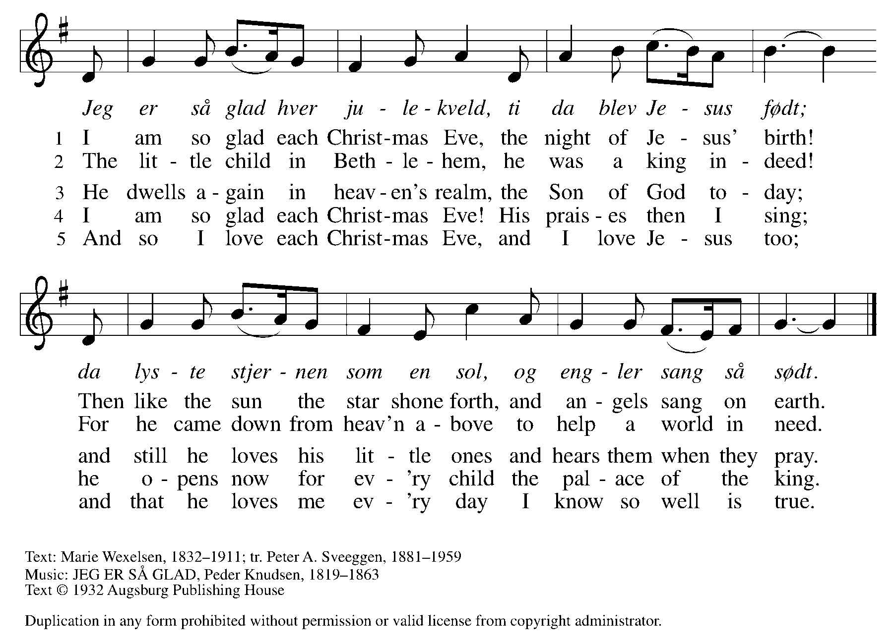  Carol  It came upon the midnight clear, That glorious song of old,  From angels bending near the earth To touch their harps of gold!  “Peace on the earth, good will to men, From heaven's all gracious King!”  The world in solemn stillness lay to hear the angels sing.  Still through the cloven skies they come With peaceful wings unfurled  And still their heavenly music floats O'er all the weary world;  Above its sad and lowly plains They bend on hovering wing.  And ever o'er its Babel sounds The blessed angels sing.  Yet with the woes of sin and strife The world hath suffered long;  Beneath the angel-strain have rolled Two thousand years of wrong;  And man, at war with man, hears not The love song which they bring:  O hush the noise, ye men of strife, And hear the angels sing.  For lo! the days are hastening on, By prophet bards foretold,  When, with the ever-circling years, shall come the Age of Gold;  When peace shall over all the earth Its ancient splendors fling,  And all the world give back the song Which now the angels sing.  We give you thanks, O God, that in this bread and cup of Christ's very life, you give us food for our journey. As you led the magi by a star, as you brought the holy family home again, guide us on the way unfolding before us. Wherever we go, may our lives proclaim good news of great joy in Jesus Christ our Lord. Amen.  Ushers will begin from the front and midway back to light the candles of those sitting on the aisle.  Stille Nacht  Silent night, holy night! All is calm, all is bright  Round yon virgin mother and child.  Holy infant, so tender and mild,  Sleep in heavenly peace, Sleep in heavenly peace.  Silent night, holy night! Shepherds quake at the sight;  Glories stream from heaven afar,  Heavenly host sing, alleluia!  Christ, the Savior is born! Christ, the Savior is born!  Silent night, holy night! Son of God, love’s pure light  Radiant beams from thy holy face,  With the dawn of redeeming grace,  Jesus, Lord at thy birth, Jesus, Lord at thy birth.  Benediction  May he who by his Incarnation gathered into one, things earthly and heavenly, fill you with the sweetness of inward peace and goodwill; and the blessing of God Almighty, the Father, the Son, and the Holy Spirit, be upon you and remain with you always. Amen.  Antioch  Joy to the world! The Lord is come;  Let earth receive her King;  Let every heart prepare him room,  :/: Repeat the sounding joy.:/:  Joy to the world! The Savior reigns;  Let men their song employ,  While fields and floods, rocks, hills and plains,  /:And heaven, and nature sing.:/:  He rules the world with truth and grace,  And makes the nations prove  The glories of his righteousness,  :/:And wonders of his love.:/:  Postlude Rhaposodie Sur Des Noëls  E. Gigout  Bulletin liturgy and hymnody reprinted under CCLI license #1821244 and or OneLicense.net #A-704053 |  | Choral Anthem  Offertory  Please stand.  Offertory Prayer  Please be seated.  Communion Hymns  Post Communion Prayer  Please stand as you are able.  Post-Communion Hymn

Welcome and Merry Christmas

Pastor Rev. Arden D. Haug
Organist Kenneth Vigne
Choir Director Dawn Allan
Soloist Debra Gilroy
Musicians Elizabeth York, violin; Rachel Haug Root, flute;
Keith Root, bassoon; Josh Schwalbach, bass;
Jamie Gorski, trumpet;
Acolytes Nicolas, Stephanie and Dominik Amann
Worship Assistant Kathy Hering
Reader Jean Carlson and Winnie Ulland
Usher Anita Duder and Bruce Sabatke
Communion Servers Renate Amann, Janna Haug
and Denise Wilkens
Altar Server Kathy Hering

Thank you also for the lovely poinsettias provided by:
John Bergford | In memory of Bev Bergford, John & Katherine Bergford
Bob and Kristin Brownson | In Memory of Marcia Ocethoudt
Jean and Bruce Carlson | In memory of Esther & Martin Carlson, Marcella & Avery Hyslop
Marty Carlson and Mary Knoblauch
Casey and Andrea Christy
Phyllis Dahl
Rick Gripentrog | In memory of Warren, Julane and Lon Gripentrog
Ross Formell and Susanne Haas
David and Carolyn Hagford | In memory of Kimberly Susan Hagford
Kathy and Mark Hering | In memory of Grover & Jerry Webster, Linda McCall
Ellie Holmquist | In honor of my family
Mike and Cindy Huttner | In memory of Gloria Froelich and William Huttner
Ruth Lee
Eivor Lund
John Madson | In memory of Joyce Madson
Todd and Katie Messerli
Linda Nelson | In memory of Orval & Lucille Nelson, Matthew Nelson
Laura Nortwen | In memory of Dallas Nortwen & Gwen Greenbank
Patricia Nortwen | In memory of Dallas Nortwen & Shirley Decker
Rick and Suzanne Pepin | In memory of Jane Schuldt
Bruce and Mary Sabatke
Jan Stewart | In memory of Dick Stewart
Peter Van Bergen and Cathy Carlson | In honor of our parents

Poinsettias may be taken home after the 10:00 Candlelight Service. If you do not remember what you ordered, please check the sheet on the Christy Room door

